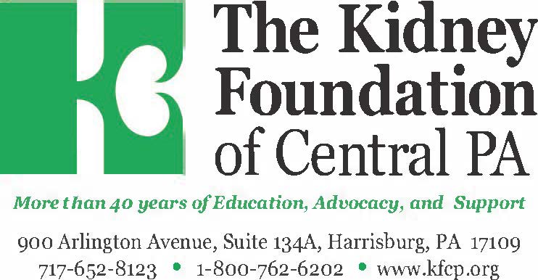

PATIENT & FAMILY CELEBRATION DAY
IN HARMONY WITH YOUR WITH YOUR HEALTH!

When: Sunday, March 22, 2020 • Time: 12pm to 3pm
Where: Best Western Premier Central Hotel, & Conference Center 800 East Park Drive, HARRISBURG Pa 17111.

Join KFCP for a fun-filled day with friends and family, good food, and fabulous prizes! Patient + 1 guests are FREE.
We suggest a minimum $10 donation for each additional guest. All proceeds from this event benefit the Patient & Family Celebration Day.

* Pre-Registration is REQUIRED
-Ask your Social Worker for a registration form
• Vendor Activities • Prizes & Giveaways

